**Week of 5/13/22**

Info:

During this week we worked on getting the controller pieces updated so that way everything would fit properly, and we had the files to edit in case anything went wrong.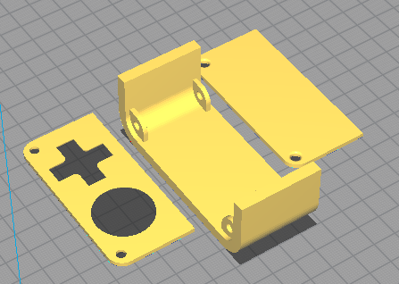

Also this week Parker worked on trying to get a prototype for the d-pad working by soldering different pieces to a board that will be put into the controller handle.

On top of that Will joined our group in the middle of the week and has been helping to work on the printers (There are no pictures of this). There was also work done on the Makerbot by Jayson, while he downloaded more ROMS to put onto the raspberry pi, and joked around most of the week.

The following slides are pictures of all the soldering this week that was done.

